# UNIT 4

**Networking**



Picture 4.1

**Learning Outcomes**: By the end of the lesson, the students are expected to be able to use appropriate English

to:

* identify and explain kinds of network hardware and its function
* explain the definition of network and its hardware components
* identify and explain kinds of network topologies
* identify and make sentences using if-clause type 1

**1.1 Explaining a network and network hardware**

**Exercise 1**: Below are hardware components used in creating a network. Match the words 1-8 to the descriptions a-g.

|  |  |
| --- | --- |
| 1. A modem 2. A repeater 3. A bridge 4. A router 5. A gateway 6. A switch 7. A hub 8. A wireless access point | 1. is an entrance to another network 2. channels incoming data but maintains the bandwidth speed. 3. allows wireless devices to connect to the network 4. modulates and demodulates the data into a digital or an analog signal 5. channels incoming data but shares the bandwidth among the devices present on a network 6. sends the digital signal further on in the network 7. connects networks and sends packages of data between them 8. connects networks that use the same protocol |

**Exercise 2**: Look at the sample of a Local Area Network (LAN). Then, answer the following questions.

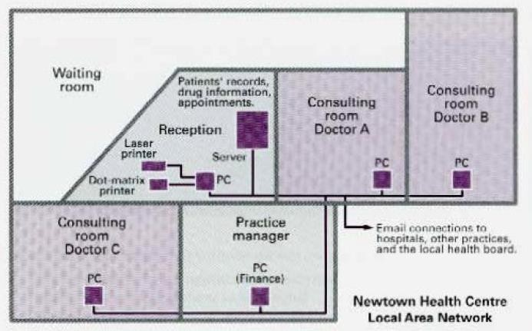

Picture 4.2

* 1. Who are the users?
  2. What kind of hardware is used?
  3. What do the doctors use it for?
  4. What do the receptionists use it for?
  5. What does the practice manager use it for?

**Exercise 3**: With the help of this diagram, answer the following questions.

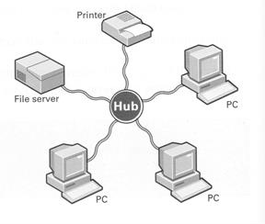

Picture 4.3

1. What is a *network*?

Network is a connection between 2 devices, usually computer, that can be used to share resource, exchange information, allows a variety of equipment types to transfer information in a near-seamless fashion.

1. What are its hardware components?

The most essential hardware components are **Motherboard, CPU, RAM memory, IO system, power supply, video display controller, Bus and hard disk drive**.

1. What is the difference between a *local area network* and *wide area network*?

- LAN covers small area i.e. within the building.

- While WAN covers large geographical area.

1. What advantages do you think networks have?

* **Network** users can communicate by **email** and **instant messenger**.
* **Data** is easy to **backup** as all the data is stored on the **file server**.

**Exercise 4:** Read the following text and do the following exercise.

**Networks**

**Local Area Networks (LANs)**

Networking allows two or more computer systems to exchange information and share resources and peripherals.

LANs are usually placed in the same building. They can be built with two main parts of architecture: **peer-to-peer**, where two computers have the same capabilities, or client server, where one computer acts as the **server** containing the main hard disk and controlling the other **workstations** or **nodes**, all the devices linked in the network ( e.g. printers, computers, etc.).

Computers in a LAN need to use the same protocol, or standard of communication. Ethernet is one of the most common protocols for LANs.

A router, a device that forwards data packets, is needed to link a LAN to another network,

e.g. to the Net.

Most networks are linked with cables or wires but new **Wi-Fi**, **wireless fidelity**, technologies allow the creation of **WLAN**s, where cables or wires are replaced by radio waves.

To build a WLAN you need **access points**, radio-based receiver-transmitters that are connected to the wired LAN, and **wireless adapters** installed in your computer to link it to the network.

**Hotspots** are WLANs available for public use in places like airports and hotels, but sometimes the service is available outdoors (e.g. university campuses, squares, etc.).

**Wide Area Networks (WLANs)**

WANs have no geographical limit and may connect computers or LANs on opposite sides of the world. They are usually linked through telephone lines, fiber-optic cables or satellites. The main transmission paths within a WAN are high-speed lines called **backbones**.

Wireless WANs use mobile telephone networks. The largest WAN in existence is the Internet.

*Professional English on the Use ICT (2007:50)*

Read and correct the following statements.

1. LANs link computers and other devices that are placed far apart.
2. In a client-server architecture, all the workstations have the same capabilities.
3. The word protocol refers to the shape of the network.
4. Routers are used to link two computers.
5. Access points don’t need to be connected to a wired LAN.
6. Wireless adapters are optional when you are using WLAN.
7. Hotspots can only be found inside a building.
8. The Internet is an example of a LAN.
9. Wireless WANs use fiber and cable as linking devices.

**Exercise 5:** Use the words in the box to complete sentences.



**LAN**

**nodes**

**hub**

**backbones**

**WLAN**

**peer-to-peer server**

1. All the PCs on a LAN are connected to one , which is a powerful PC with a large hard disk that can be shared by everyone.
2. The style of NODES networking permits each user to share resources such as printers.
3. The star is a topology for a computer network in which one computer occupies the central part and the remaining PEER TO PEER are linked solely to it.
4. At present Wi-Fi systems transmit data at much more than 100 times the rate of a dial-up modem, making it an ideal technology for linking computers to one another and to the Net in a . BACKBONE
5. All of the fiber-optic WLAN of the United States, Canada, and Latin America cross Panama.
6. A HUB joins multiple computers (or other network devices) together to form a single network segment, where all computers can communicate directly with each other.

**Exercise 6:** Read Katharina’s email to Agatha. Complete this email with the words in the

box.

|  |  |  |  |
| --- | --- | --- | --- |
| equipment | internet | LAN | recommend |
| remote | should | VPN | WAN |

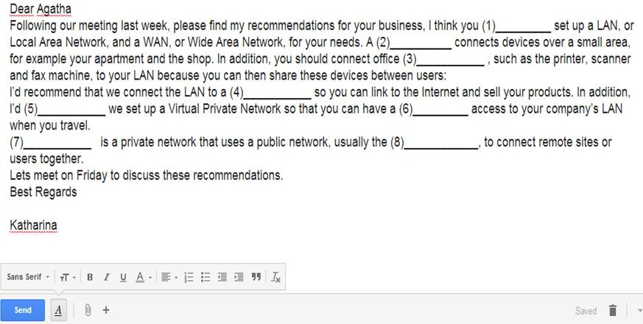

1. should 2. lan 3. equipment 4. wan 5. recommend 6. remote 7. vpn 8. internet

**1.2 Identifying Network Topologies Exercise 7**: These following diagrams show four network topologies. Match each with

the correct name.

**ring bus star mesh**

|  |  |  |  |  |  |  |  |  |  |  |  |
| --- | --- | --- | --- | --- | --- | --- | --- | --- | --- | --- | --- |
|  |  |  |  |  |  |  |  |  |  |  |  |

|  |  |  |  |
| --- | --- | --- | --- |
| 1. | 2. | 3. | 4. |

Picture 4.3

**Exercise 8**: Read this following text to check your answer for exercise 7.

**NETWORK TOPOLOGY**

Topology refers to the shape of a network. There are three basic physical topologies. One is a **star** system. In this topology, there is a central device to which all the computers/workstations are directly connected. This central position can be occupied by a server, or a hub, a connection point of the elements of a network that redistributes the data. Another type is a **ring** system. This is a network that has each workstation linked to two others. In a **bus** system there is a central or main cable which is called a bus, and each workstation is linked to it. There are also mixed topologies, like the **tree**, a group of stars connected to a central bus. Some large networks use a **mesh**. In this topology, each workstation is linked to several others. This has one big advantage: if one connection breaks, the data can use other connections. Therefore, it is difficult to break a mesh network.

**Exercise 9**: Refering to exercise 7 and 8 above. Identify which topologies these

statements refer to.

1. If one of the computer fails, the whole network will be affected.
2. If we remove a computer from the network, it won’t affect the other computers.
3. If the main cable fails, the whole network will fail.
4. If the central server fails, the whole network will fail.
5. If a cable breaks, the whole network will be affected.
6. If a computer fails, it won’t affect the other computers.

**Exercise 10**: Refering to exercise 9. You see that If-Clause Type 1 are used the the

sentences above. Here are more explanation on the If-Clause Type 1.

|  |  |  |
| --- | --- | --- |
| **Note** | **Description** | **Examples** |
| **Formula** | If + simple present**,** simple future **If clause (condition)**, **Main clause (result)**  **Meaning:**  If this thing happens, that thing will happen. | * If the main cable fails, the whole network will fail. * The whole network will fail if the main cable fails. * If a cable breaks, the whole network will be affected. * The whole network will be affected if a cable breaks. |
| **The Order** | The order of the clauses is not fixed. When you change the order of the clauses, you need to pay attention to the punctuation and pronoun, but the  meaning is identical. |
| **Function** | These sentences are based on facts, and they are used to make statements about the real world, and about particular situations. In type 1 conditional sentences, the time is the **present** or **future** and the  situation is **real**. |
| **If-Clause Type 1 with Modals** | In type 1 conditional sentences, you can also use modals in the main clause instead of the future tense to express the degree of certainty, permission, or a recommendation  about the outcome. | * If a computer fails, it won’t   affect the other computers.   * It won’t affect the other   computers if a computer fails. |

**Exercise 11**: Refering to the If-Clause Type 1 that you learned, complete the following

sentences.

1. If she (need) a computer, her brother (give) her his computer.
2. If she (read/not) the Computer Networking module and her notes, she (pass/not) the test.
3. If they (invite/not) me to the computer workshop, I (go/not)

.

1. The administration staff (accept) WILL ACCEPT, TURN INhis thesis draft if Rama (turn in)

his thesis draft on time.

1. If you (want) WANT, WILL SET UP a remote access to your company’s LAN, you (set up)

a Virtual Private Network.

1. If Anugrah (need) WANT, WILL NEEDto connect devices over a small area, he (need)

to set up a LAN.

**Exercise 12**: Link each action (1-10) with a suitable consequence (a-j). Then, combine

them using if-clause.

Example: ***If*** *you place a floppy disk near magnet, you will destroy the data*.

1. The cursor moves to the left
2. The computer hangs
3. It is not lost when you switch off
4. You damage the drive
5. You copy the screen
6. You have access to the network
7. You destroy the data
8. It runs faster
9. Your phone bills are lower
10. The cursor moves accross the screen
11. You place a floppy disk near a magnet
12. You press print screen
13. You input the correct password
14. You add memory to a computer
15. You move the mouse to the left
16. You store data in RAM
17. You use a faster modem
18. There is a memory fault
19. You press the arrow key
20. You move a CD-ROM drive with the disk in place

2e 7i 3f 9j 1g 8b 5a 10d 6c 4h

**Exercise 13**: Now make a short dialog that uses the If-Clause Type 1 that you learned. Perform the dialog in front of the class.